Week 2

You should be able to complete the following programs by the end of the week. You should

keep the code somewhere safe, in an organised way. GitHub is ideal. Wherever you choose,

you should ensure that the work is safe and backed up.

Possible solutions will be uploaded to the main module GitHub repository every week. If you

follow that repo you should be able to receive notifications.

In the following, bold text indicates where a user is typing.

1. Last week you wrote a program that printed out a cheery greeting including your

name. Take a copy of it, and modify it so that the user enters their name at the

keyboard, and then receives a greeting. For example:

Hello, what is your name? Mr Apricot

Hello, Mr Apricot. Good to meet you!

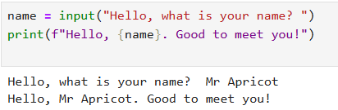

2. Write a program that prompts a user to enter a temperature in Celsius, and then displays the corresponding temperature in Fahrenheit, like so:

Enter a temperature in Celsius: 32.5

32.5C is equivalent to 90.5F.

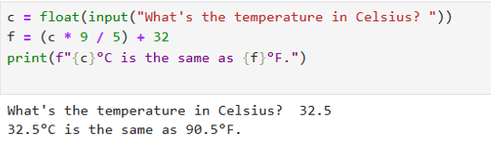

3. The Head of Computing at the University of Poppleton is tasked with dividing a

group of students into lab groups. A lab group is usually 24 students, but this is

sometimes varied to create groups of similar size. Write a program that prompts for

the number of students and group size, and then displays how many groups will be

needed and how many will be le over in a smaller group.

How many students? 113

Required group size? 22

There will be 5 groups with 3 students left over.

For bonus credit, see if you can fix the grammar in the output. So if there were 101

students in groups of 20 the output would be:

There will be 5 groups with 1 student left over.

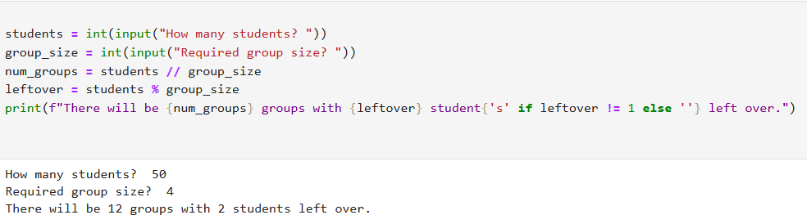

4. A kindly teacher wishes to distribute a tub of sweets between her pupils. She will

first count the sweets and then divide them according to how many pupils attend

that day. Write a program that will tell the teacher how many sweets to give to each

pupil, and how many she will have le over.

